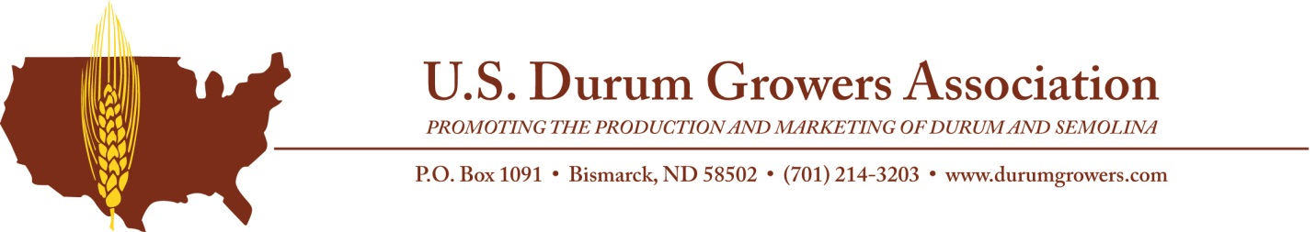

For Immediate Release Contact: Deana Wiese, Executive Director
Nov. 12, 2019 701-214-3203
office@durumgrowers.com

Fisher and Doe Receive Amber Awards

Bismarck, N.D. – Jay Fisher, president of Fisher Research LLC and N.D. Representative from District 5, of Minot, N.D., and Russell Doe, durum producer, of Reeder, N.D. received 2019 Amber Awards from the United States Durum Growers Association (USDGA) during the Crop Outlook and International Durum Forum banquet on Nov. 11 in Minot, N.D. The Amber Award recognizes individuals who have shown outstanding commitment and dedication to the durum industry in the areas of production, research or education.

Fisher was raised in Kidder County, holding a bachelor’s degree and master’s degree from North Dakota State University, he has called Minot, N.D., his home for nearly 40 years. He and his wife, Marlys, a registered nurse at Trinity Cardiac Rehab, have four children and four grandchildren. He is passionate about agriculture and spent over 37 years as agronomist/director at the North Central Research and Extension Center (NCREC).. His work with NCREC included evaluation and dissemination of research activities on herbicide residue in Hard red spring and durum wheat and research on sulfonylurea chemical combinations for false chamomile control in durum. He also supported providing genetically pure, foundation grade seed to North Dakota Hard red spring and durum wheat producers. Fisher is currently the president of Fisher Research LLC, a precision and value-added agriculture company, and serves as a N.D. Representative from District 5.

Doe has been a durum producer in Reeder, N.D., for 42 years. He has also worked as a custom harvester in Oklahoma and North Dakota for the past 25 years. Doe served as a USDGA board member for nine years including two years as president. During his years on the USDGA board of directors, Doe’s passion for the industry showed while attending countless meetings and putting in endless hours to address durum grading issues.

“Jay and Russell are very deserving of this award,” says USDGA President Blake Inman. “Their long-term dedication and contributions to the durum industry have and will continue to have a lasting positive impact.”

USDGA’s mission is to increase the profitability of durum production through effective market development and promotion and coordinated communication and educational outreach. For more information, visit www.durumgrowers.com.

###

