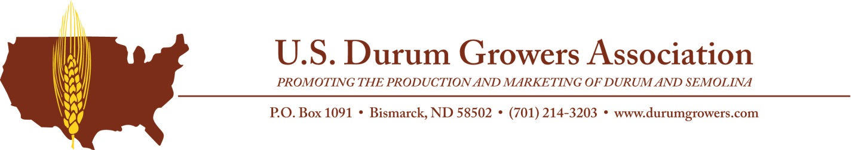

For Immediate Release Contact: Deana Wiese, Executive Director
November 14, 2019 U.S. Durum Growers Association
701-214-3203
office@durumgrowers.com

U.S. Durum Growers Association elects leadership

Bismarck, N.D. – The U.S. Durum Growers Association (USDGA) recently elected four directors to its board and selected its 2019-2020 officers.

Steve Perdue, Ray, N.D., was elected to serve as a director from the northwest district. Tim Goeser, Munich, N.D., was elected to serve as a director from the east district. Lanny Jones, Joplin, Mont., was elected to serve as a director from the Montana district. Arvin Larson, Williston, N.D., was elected to serve as an at-large director. The directors were selected by the USDGA membership to serve three-year terms.

The 2019-2020 executive officers are: President Blake Inman, Berthold, N.D.; 1st Vice President Scott Monke, Regent, N.D.; 2nd Vice President Jordon Hawbaker, Portal, N.D., and Secretary/Treasurer Arvin Larson, Williston, N.D. The officers were selected by the USDGA board of directors to serve one-year terms.

USDGA’s mission is to increase the profitability of durum production through effective market development and promotion and coordinated communication and educational outreach. For more information, visit www.durumgrowers.com.

###

